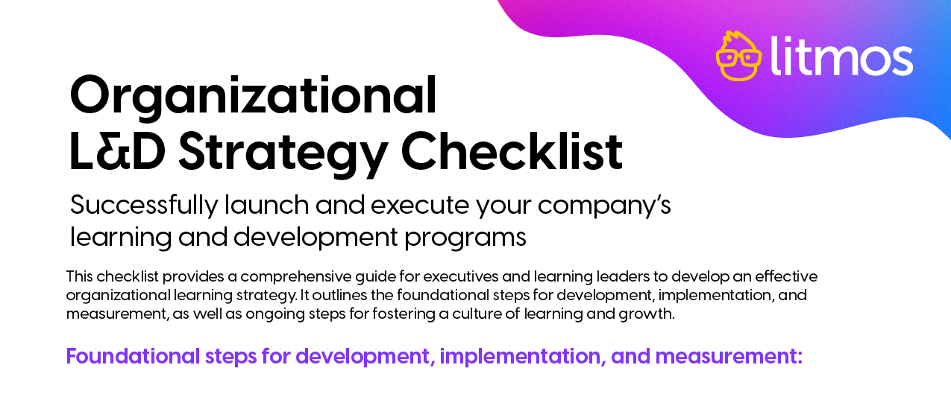
STATUS | TASK | OWNER | DUE DATE | NOTES
1. Assess organizational needs
 | Identify future skills needs (based company strategies, trends, market changes, etc.)
 | Gather feedback on L&D needs from key stakeholders.
2. Determine impact, viability, and priority of learning objectives
 | Impact: Determine which learning objectives have the most significant impact on the organization.
 | Viability: Assess whether there are enough resources (time, budget, instructors, materials) to support each learning objective and desired outcome.
 | Priority: Consider the resource availability above to determine which learning objectives your program can prioritize.
3. Define and align learning objectives
Define: Clearly define what objectives you want your employees to achieve through the learning program(s).
Examples of employee learning objectives include: specific skills, knowledge, competencies.
Define: Determine criteria for measuring success.
Example: If you want to improve customer service skills, track customer satisfaction scores before and after training.
Align: Ensure that learning objectives align with the strategic goals for your organization.

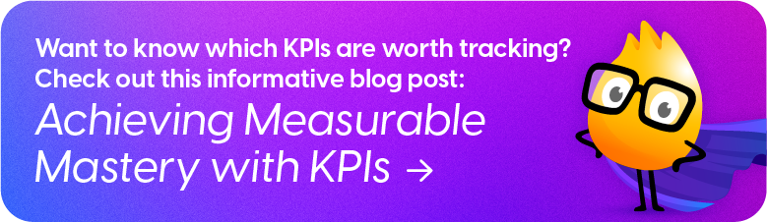

STATUS | TASK | OWNER | DUE DATE | NOTES
4. Design the learning program
Choose your learning format(s)! Determine which types of learning experience best suits the employee and organizational objectives you have identified above.
Examples of learning formats include: in-person training, online courses, workshops, coaching, mentoring, etc.)
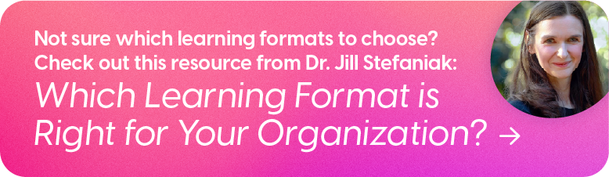
Choose your learning delivery method(s)! Choose a blend of learning methods to accommodate different learning and organizational objectives.
Examples of learning delivery methods include: self-paced, instructor-led, collaborative, etc.)
5. Evaluate and select learning tools
 | Evaluate Learning Management System (LMS) or other platforms for tracking and delivering learning programs.
 | Evaluate and select a learning content creation tool (if not included in your LMS or training platform software).
 | Evaluate whether the tools being considered meet the accessibility needs of your employees and the accessibility standards of your organization.
Select the tool(s) based on the criteria, strategic goals, and learning needs of your organization and employees.
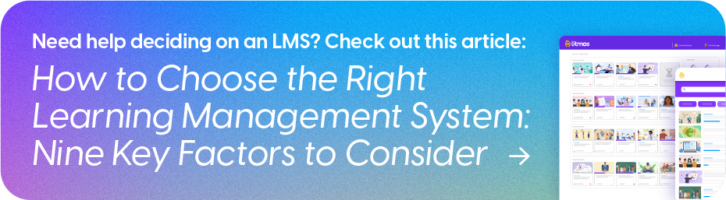
6. Develop a communication plan
Does your communication plan outline the benefits of your learning program for employees?
Examples of employee benefits include: professional development, career advancement, new skills, personal growth, etc.

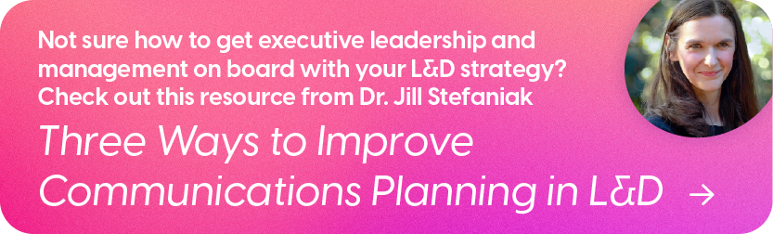
 | Does your communication plan outline the connection between your learning program and organizational goals?

STATUS | TASK | OWNER | DUE DATE | NOTES
 | Does your communication plan provide an overview of the learning opportunities available and details about how to access them?
Does your communication plan leverage a variety of channels throughout your organization?
Examples of communications channels for internal messaging include: company-wide intranet, company-wide emails, team-wide meetings, conference calls, etc.
Do your organization’s leadership know about your L&D program? Get buy-in to ensure cascading of information and sponsorship!

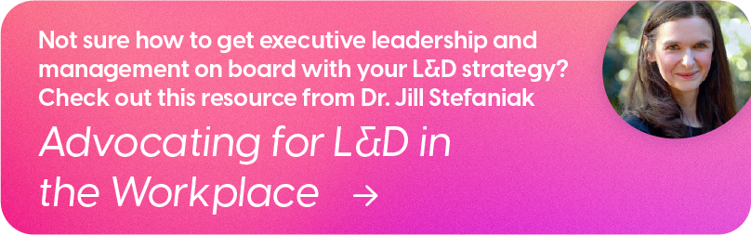
7. Implement the learning program strategy
 | Launch: Execute your learning program.
 | Monitor: Track participation and engagement of your learning program.
 | Engage: Leverage your LMS to engage inactive learners, gather feedback, and continue monitoring progress.
 | Optimize: Adjust your strategy based on initial feedback and observations.
8. Measure and improve your learning strategy
Revisit your initial measurement strategy to ensure it measures the impact of learning on employee and organizational objectives.

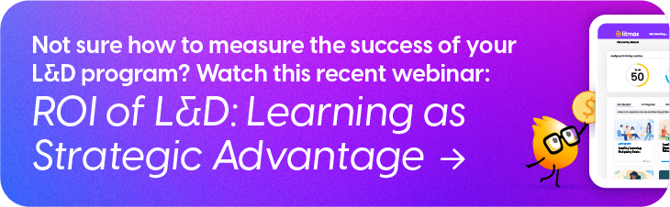
 | Evaluate the effectiveness of your learning program through internal assessments, employee feedback mechanisms, and key metrics.

